Public Finance Information System(PFIS)

Weekly Report

By:Simon Temesgen

Position:Senior Software Programmer

Date :March 9 2026

Microservices Architecture and Monolithic architecture Research and Implementation Report

1. Introduction
Over the past few weeks, extensive research, practice, and experimentation were conducted on modern software architecture patterns, focusing primarily on Microservices Architecture and its comparison with traditional Monolithic Architecture. The practical implementation included developing several independent services using Spring Boot, Next.js, and PostgreSQL.
The goal of this report is to present the architectural concepts, comparisons, technologies used, implementation experience, and recommendations for future system development.

2. What is Monolithic Architecture
Monolithic architecture is a traditional software design approach where all components of an application are tightly integrated into a single codebase and deployed as one unit. This includes the user interface, business logic, and database access layers.
Characteristics:
- Single codebase
- Single deployment unit
- Shared database
- Tight coupling between components and modules
Advantages:
- Simpler initial development
- Easier debugging in small systems
- Straightforward deployment
Disadvantages:
- Difficult to scale individual components
- Large codebase becomes hard to maintain
- Changes in one module may affect the entire system
- Slower development for large teams
- Everything is stored on single database and issue on one modules affects the other modules

3. What is Microservices Architecture
Microservices architecture is a modern approach where an application is divided into multiple independent services. Each service focuses on a specific business capability and communicates with other services through APIs.
Characteristics:
- Independent services
- Separate deployment
- Independent(distributed) databases
- Lightweight communication (REST, messaging)
Advantages:
- Independent scaling
- Faster development with multiple teams
- Technology flexibility
- Fault isolation
Disadvantages:
- Higher operational complexity
- Distributed system challenges
- Network communication overhead
- Requires DevOps maturity

4. Comparison: Monolithic vs Microservices
Monolithic Architecture:
- Single deployable application
- Shared database
- Tight coupling
- Easier to start but harder to scale
Microservices Architecture:
- Multiple independent services
- Independent deployment
- Loose coupling
- Easier scaling and maintenance for large systems

5. Implemented Microservices
During the practical implementation, several independent services I created:
User Service with Keycloak:
Responsible for user management, authentication, and authorization.
Core Service:
Handles shared system logic and core platform functionality.
Translation Service:
Provides multilingual translation support for system data and user interface labels.
Form Service:
Implements a Dynamic Form Builder allowing the system to generate forms dynamically based on metadata stored in the database.

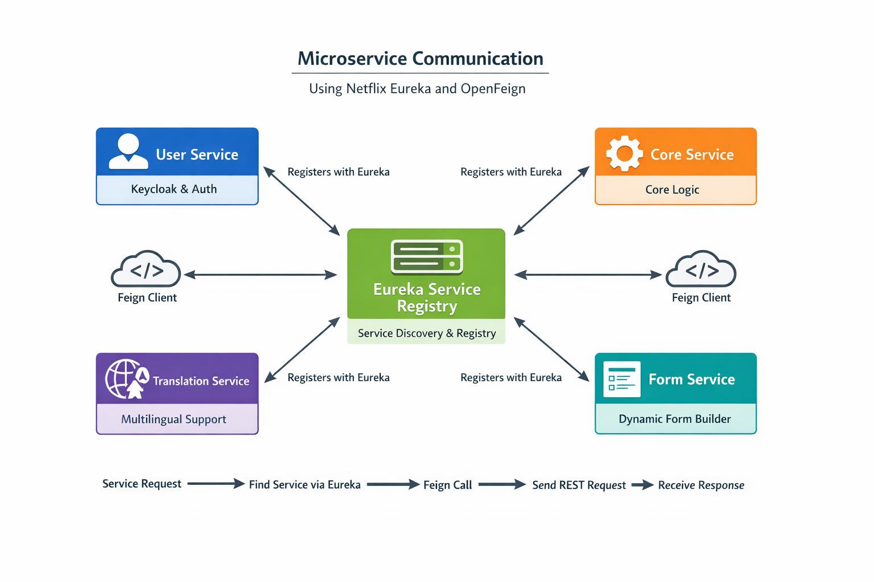

6. Dynamic Form Builder Concept
The Dynamic Form Builder allows administrators to define forms without modifying the application code. Forms are generated dynamically using metadata definitions stored in the database.
Features:
- Dynamic form creation
- Field configuration
- Lookup relationships
- Validation rules
- Integration with other services

7. Benefits Observed During Implementation
During the development process, several benefits of microservices architecture were observed:
- Independent service development
- Clear separation of responsibilities
- Easier scalability
- Improved modularity
- Flexibility in future system expansion

How Each services communicate
In a microservices architecture, services run independently and communicate with each other through lightweight protocols, usually HTTP-based REST APIs or messaging systems. To enable dynamic communication between services without hard‑coding service addresses, infrastructure components such as Service Discovery and API clients are used.

1. Service Discovery with Netflix Eureka
Service discovery allows microservices to locate and communicate with each other dynamically. In many Spring Boot microservice systems, Netflix Eureka is used as a service registry.

How Eureka Works:
1. A central Eureka Server acts as a registry that stores the locations of all services.
2. Each microservice (User Service, Core Service, Translation Service, Form Service) registers itself with the Eureka Server when it starts.
3. The service sends periodic heartbeats to Eureka to indicate that it is still alive.
4. Other services query Eureka to find the network location of the service they want to call.

2. Inter‑Service Communication using OpenFeign
OpenFeign is a declarative HTTP client used in Spring Cloud microservices. It simplifies communication between services by allowing developers to define interfaces instead of writing complex HTTP client code.
How OpenFeign Works:
1. A service defines a Feign Client interface annotated with @FeignClient.
2. The name of the target service is specified in the annotation.
3. When a method in the interface is called, Feign automatically creates an HTTP request.
4. The request is routed to the correct service instance using information retrieved from the Eureka Service Registry.

3. Example Microservice Communication Flow
In the implemented system, several independent services were created: User Service, Core Service, Translation Service, and Form Service. Each service registers itself in Eureka. When one service needs data from another, it uses an OpenFeign client.
Example Flow: Form Service requesting translation data:
1. Form Service calls Translation Service using a Feign client.
2. Feign asks Eureka for the location of Translation Service.
3. Eureka returns the available service instance.
4. Feign sends an HTTP request to the service instance.
5. Translation Service processes the request and returns the response.

4. Benefits of Using Eureka and OpenFeign
Loose coupling between services.
Dynamic service discovery without hard‑coded URLs.
Load balancing across multiple service instances.
Improved scalability and fault tolerance.
Simplified REST communication between microservices.

